Unveiling market insigts

ANALYSING SPENDING BEHAVIOUR AND IDENTIFYING OPPORTUNITIES FOR GROWTH

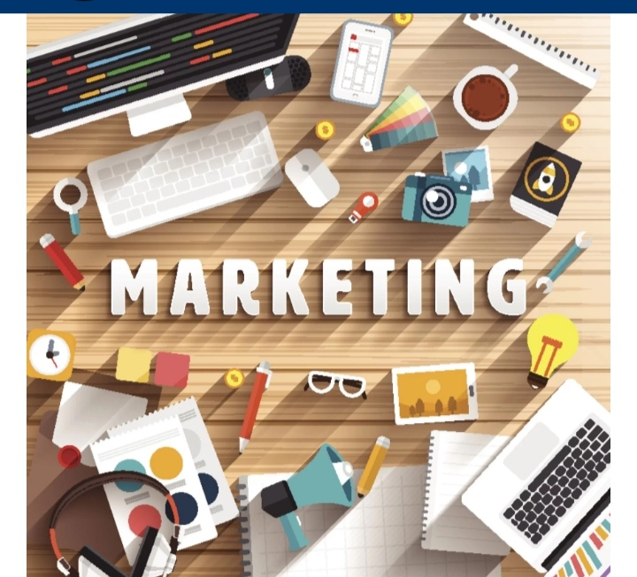

1.INTRODUCTION:

1.1 OVERVIEW

Wholesaling or distributing is the sale of goods or merchandise to retailer to industrial,commercial,institutional or other professional businessman to other wholesalers and related subordinated services.In general,it is the sale of goods in bulk to anyone,either a person or an organization,other than the end consumer of that merchandise.wholesaling is buying separatedgoods in bulk quantity, usually directly from the manufacturer or source consumption, at a discounted rate. The retailer then sells the goods to the end consumer at a higher price making a profit. The and production of marketed food are spatially

* 1. **Purpose**

The goal of the field of market insights is to learn about and analyse the market. Data on the market, consumers, and competitors must be gathered, analysed, and interpreted by individuals in the role. Marketing insights benefit both parties by meeting your target audience’s needs and wants while also profiting.

**2.PROBLEM DEFINITION & DESIGN THINKING**

* EMPATHY MAP
* BRAINSTORM
  1. **EMPATHY MAP**
* An empathy map is a collaborative tool teams can use to gain a deeper insight into their customers.
* Register the **Mural** website to create the map.
* In my term we are discussed and collect the details.

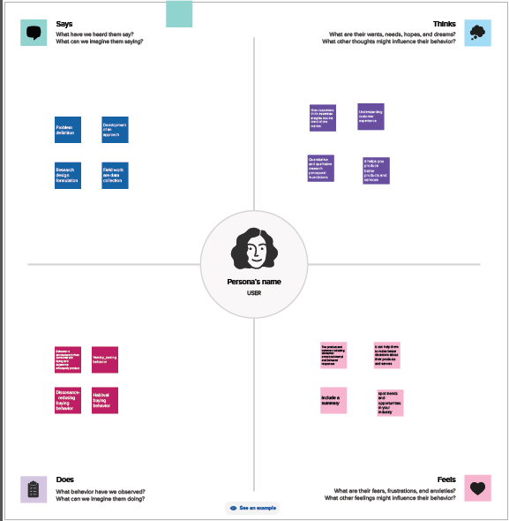

**2.2 IDEATION &** **BRAINSTORMING MAP**

* Brainstorming is a larger or small group discussion that encourages students to generate a wide range of perspectives or potential next steps or solutions reading a specific topic.
* Use **MURAL** website to create.

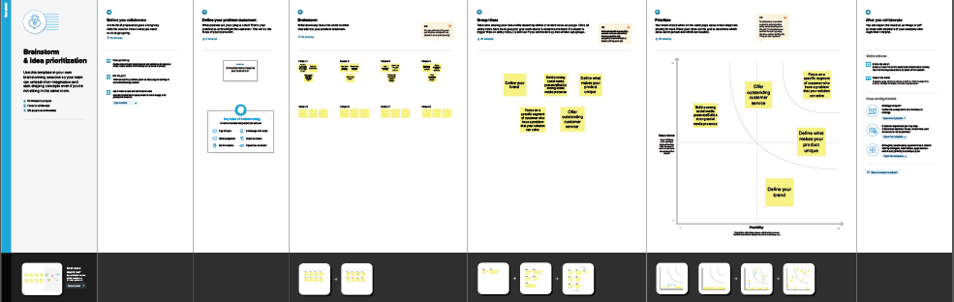

**3. RESULT**

* Collect the **Dataset.**
* Dataset connect with **Tablue**

**COLLECT THE DATASET**

We are **collect** thedataset in online.

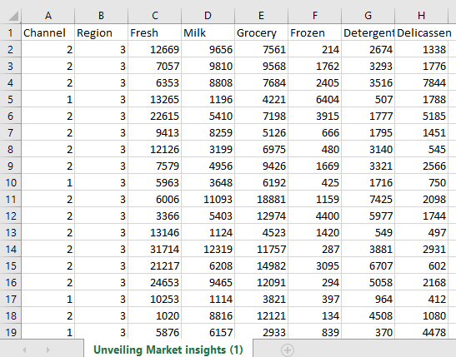

**DATASET CONNECT WITH TABLEAU**

* Installed the tableau desktop.
* Insert the dataset in tableau.

**DATA PREPARATION**

* Prepare the data for visualization.
* We give some changes for the dataset.

**DATA VISUALIZATION**

* We introduced graphical representation to visualization.
* ***KPI***
* ***Region Wise Detergent paper and grocery***
* ***Region wise Milk***
* ***Channel Wise frozen and Delicatessen***
* ***Region Wise Delicatessen and Detergent paper***
* ***Channel Wise grocery and Detergent paper***
* ***Region Wise Delicatessen***
* Use this subheading to give the graphical visualization.
* Graphical representation like ***bar chart, pie chart, line chart, butterfly chart and arrow chart.***

**DASHBOARD**

* A Dashboard is a graphical user interface (GUI) that displays information and data in an organize.
* Combine two or more sheets create a dashboard

**DASHBOARD 1**

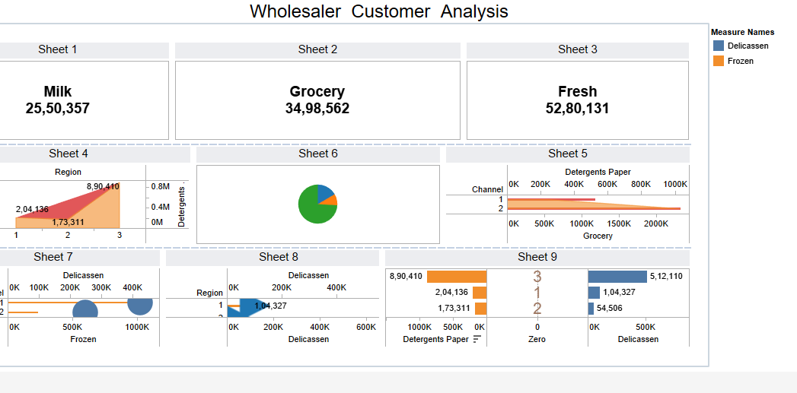

**STORY**

* A data story is a way of presenting data and analysis in a narrative format, with the goal of making the information more engaging and easier to understand.

**STORY CREATION**

* + - * 1. Create story points
        2. Explore layout options.
        3. Format a story.
        4. Resize captions.
        5. Fit the sheets are one by one.
        6. Format a story’s shading, title, and text objects.

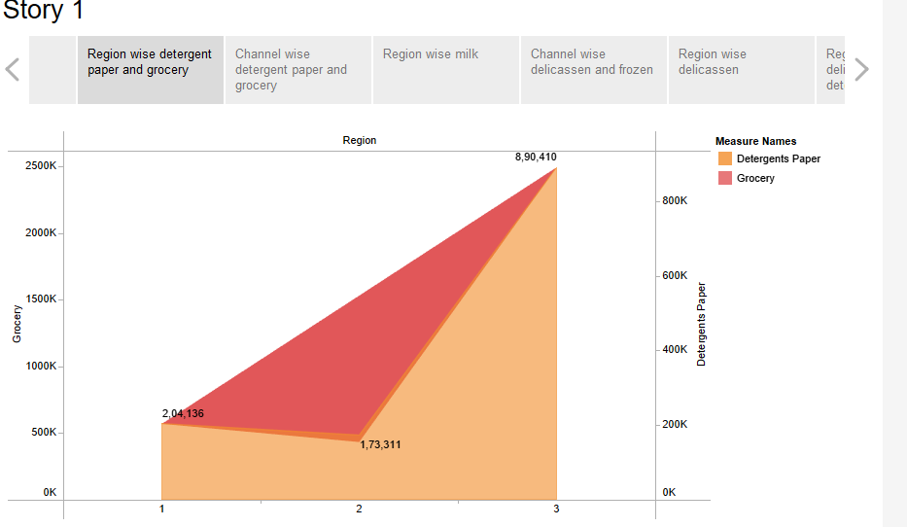

**PERFORMANCE TESTING**

* **Amount of Data Rendered to Tableau**

* The amount of data that is rendered to a Tableau depends on the size of the dataset.
* **Utilization of Data Filters**

* **No of Calculation Fields**
* **Delicatessen**
* **Detergent papers**
* **Fresh**
* **Frozen**
* **Grocery**
* **Milk**
* **Zero**
* **Wholesaler customer data**
* **Measure values**

* **No of Visualizations/ Graphs**

**1. KPI**

**2. Region Wise Detergent paper and grocery**

**3. Region wise Milk**

**4. Channel wise frozen and Delicatessen**

**5. Region wise Delicatessen and**

**6. Channel wise grocery and Detergent**

**7. Region Wise Delicatessen**

**4. ADVANTAGES & DISADVANTAGES**

**ADVANTAGES**

* *Maintain a Customer-Centric Approach*
* *Connect With Your Audience More Effectively*
* *Identify Opportunities for Growth*
* *Reduce Risks by Testing Concepts*
* *Make More Informed Decisions*
* *Compete More Effectively*
* *Stay on Top of Trend*

**DISADVANTAGES**

* *The biggest obstacles for market researchers*
* *Not having enough time*
* *Lack of budget*
* *Not having the right data*
* *Not having the right technology*
* *Not having the skill set*

**5. APPLICATIONS**

* Demand Forecasting
* Sales Analysis
* Advertising Research
* Positioning Research
* Market Segmentation
* Product Research
* Pricing Research
* Distribution Research
* Customer Satisfaction Research

**6. CONCLUSION**

Marketing research is crucial for ensuring that a company can understand the mindset of its customers. Based on the finding of these reports, they can develop products that can fulfill customers’ requirements.

**7. FUTURE SCOPE**

Artificial intelligence (AI) and machine learning technologies are already being used to analyze large data sets and provide predictive insights. In the future, these technologies could play an even larger role in market research, helping to identify trends and patterns in consumer behavior and preferences.

**8. APPENDIX**

**DATASET LINK**

<https://drive.google.com/file/d/1aL94WMbgMqkZYtwt2AbpomjB0hpZzocm/view?usp=sharing>

**DASHBOARD LINK**

<https://public.tableau.com/app/profile/aarthi.natarajan/viz/Dashboard_16970023552770/Dashboard1?publish=yes>

|  |  |
| --- | --- |
|  |  |

**STORY LINK**

<https://public.tableau.com/app/profile/aarthi.natarajan/viz/Story_16970031642080/Story1?publish=yes>